MEMORANDUM OF AGREEMENT
KNOW ALL MEN BY THIS PRESENTS:

This MEMORANDUM OF AGREEMENT (MOA) entered into and executed by and between:

The DEPARTMENT OF SCIENCE AND TECHNOLOGY - REGION XX,
hereinafter referred to as "FIRST PARTY", with principal office at
and represented in this Agreement by its Regional Director, XXXX;

- and -

The XXXX, hereinafter referred to as "SECOND PARTY", with principal office at , and represented in this Agreement by its
' XXXXXX;

WITNESSETH: THAT

WHEREAS, the Department of Science and Technology (DOST) has identified the Small Enterprise Technology Upgrading Program (SETUP) as one of the strategic programs under the National Science and Technology (S&T) Plan and has provided funds therefore;

WHEREAS, SECOND PARTY is in need of technical support and assistance from DOST-SETUP to improve its productivity through the implementation of the project titled, "XXXX" as a component project of the SETUP, the objectives and output of which are described in the approved project proposal (made part hereof as Annex A);

WHEREAS, FIRST PARTY has identified the following S&T interventions needed by SECOND PARTY, which shall be undertaken through this project:

  - System Improvement - Improvement of operational processes using the equipment acquired through SETUP and crafting of the vision and mission statements, among others;
  - Process Improvement - Improvement of overall production operations through standardization of operating procedures and application of relevant productivity tools;
  - Human Resource Development - Productivity improvement of workers through provision of trainings on the operation and maintenance of the new equipment;

WHEREAS, FIRST PARTY possesses the technical qualifications, commitment and sense of responsibility deemed necessary to assist and monitor the implementation of the aforesaid project;

WHEREAS, FIRST PARTY and SECOND PARTY pledge to extend their full cooperation for the effective and efficient implementation of the aforesaid project;

NOW, THEREFORE, for and in consideration of the above premises, and of the mutual covenants and stipulations hereinafter set forth, the parties hereto agree to enter into this Memorandum of Agreement under the following terms and conditions:

- FIRST PARTY shall:

  - Release funds amounting to XXXXX (PXXXXXX) to SECOND PARTY to facilitate the acquisition/fabrication of all the equipment/materials indicated in the Line-Item budget (made part hereof as Annex B). The mode of fund release shall be through electronic bank transfer from FIRST PARTY to SECOND PARTY's current/checking account with Landbank of the Philippines (LBP), opened exclusively for the project's fund-related transactions;

  - Monitor and ensure that the implementation of the above project is in accordance with the Schedule of Activities (made part hereof as Annex C);

  - Monitor, evaluate, and document project activities and identify alternative courses of action to address problems met, if any, during the implementation of the project;

  - Facilitate the collection of the monthly refunds of SECOND PARTY in accordance with the Approved Schedule of Refunds (made part hereof as Annex D) and remit the same to the Bureau of Treasury;

  - Facilitate the pullout of all tools and equipment in good working condition procured out of project funds and collect the final obligation to be computed in accordance with the computation presented in Annex B: "Computation of Final Obligation of Terminated SETUP Projects" of the SETUP Guidelines, in the event that SECOND PARTY fails to remit refunds for six (6) consecutive months or for any violation of the Memorandum of Agreement entered into by the FIRST PARTY and SECOND PARTY;

  - Place inventory tag stickers on the individual equipment acquired out of project funds;

  - Recover in behalf of DOST the full assistance if due to premature unjustified project termination or when funds are not used according to the approved purposes, or for any violation of this MOA;

  - In case of failure or termination of the project due to force majeure or fortuitous event, FIRST PARTY shall submit to the Regional Commission on Audit (COA) a written request for "Relief from Accountability" or a request for write-off and/or condonation, whichever is appropriate, consistent with the provisions of the Government Auditing Code of the Philippines (PD 1445) and Section 41, Chapter 10, Volume 1 of the Government Accounting Manual (GAM); and

  - Ensure confidentiality of SECOND PARTY's information related to its product formulation, operational processes and parameters, and financial performance.

- SECOND PARTY shall:

  - Open and maintain a separate current/checking account with the nearest Landbank of the Philippines (LBP) in their area to be used solely for the project;

  - Request LBP to tag the account restricting withdrawal without the written authorization from FIRST PARTY authorizing such withdrawal;

  - Allow FIRST PARTY to restrict withdrawal of funds from the current/checking account used solely for the project;

  - Receive funds from FIRST PARTY and issue an acknowledgement receipt/ official receipt of funds received;

  - Seek written authorization from FIRST PARTY prior to withdrawal from said account or electronically transferring the payment to the suppliers/ fabricator's bank account;

  - Ensure that funds received from FIRST PARTY in the amount of XXXX:X (PXXXXXX) are expended in accordance with the intended purpose and as indicated in the approved Line-Item Budget;

  - Liquidate the funds received and submit an Audited Financial Report (following the format in Annex E) to FIRST PARTY not later than one (1) month after the equipment commissioning/installation;

  - Issue a total of post-dated checks (PDCs) in the name of FIRST
PARTY representing the whole amount of refunds in accordance to the refund schedule, prior to receipt of funding assistance;

  - Not use the funds for money market placement, time deposits and other form of investments, and purposes/items other than those stipulated in the approved project proposal;

  - Coordinate and collaborate with FIRST PARTY in the acquisition/ fabrication of all the equipment/materials indicated in Annex B;

  - Implement the project in accordance with the approved Schedule of Activities and the identified and approved technological intervention(s);

  - Provide the appropriate site and building to house the S&T intervention­ related equipment/other facilities;

  - Provide operating funds and equipment needed in its operations and in the implementation of the project other than those indicated in the approved Line-Item Budget, as SECOND PARTY's counterpart;

  - Coordinate and collaborate with FIRST PARTY all activities to be undertaken in relation to project implementation;

  - Allow FIRST PARTY and DOST agency representatives access to its premises and facilities to monitor and collect necessary data/information during the implementation of the project;

  - Notify FIRST PARTY of any deviation in the activities and plans during the implementation of the project;

  - Be responsible for the day-to-day operation of the project;

  - Submit to FIRST PARTY the following properly filled-up Project Information Sheet (PIS) to monitor progress of the project:

    - Pre-Implementation PIS - immediately upon receipt of the confirmation of project approval, prior to the release of funds/equipment for the project; and

    - PIS for On-going project- PIS and Status Report to be submitted every end of semester of each year from the start of project implementation up to the year following full refund of the total funding assistance;

  - Acknowledge DOST-SETUP's and FIRST PARTY's assistance in all reports, products, papers, and materials produced out of project activities;

  - In case of failure to remit refunds for six (6) consecutive months, violation of any of the provisions of this Memorandum of Agreement, or termination of project, authorize/allow FIRST PARTY to pull out all tools and equipment in good working condition procured out of the project funds and settle the final obligation, if any, to be computed in accordance with Annex B of the SETUP Guidelines: "Computation of Final Obligation of Terminated SETUP Projects";

  - Should pullout of tools and/or equipment be impossible/impractical, allow the use of the facility acquired out of the project funds by other cooperators identified by FIRST PARTY;

  - In case of failure or termination of the project due to force majeure or fortuitous event, provide FIRST PARTY with all the necessary document/ information needed to support the request for "Relief from Accountability", write-off and/or condonation, whichever is appropriate, and settle final obligation, if any, based on the COA's recommendation;

  - Assist FIRST PARTY and the PSTO/CASTO/CSTO XXXX in placing inventory tag stickers on each equipment acquired out of the project funds;

  - Be responsible and accountable for the maintenance and safekeeping of all the equipment acquired out of project funds. Ownership of the equipment shall remain with FIRST PARTY until after full ownership has been transferred to SECOND PARTY upon refund completion; and

  - Put-up a sign board designed by FIRST PARTY and paid for by SECOND PARTY, measuring 4ft X 4ft, at the project site not later than two (2) weeks after receipt of the project funds, containing the following details:

PROJECT TITLE: XXX

Cooperator: XXXX

Phase I (Equipment Acquisition and Installation)
XXXXXXXXtoXXXXXXX
Phase II (Refund Period and SME Expansion/Operation) XXXXXXXX to XXXXXXXX

Source(s) of Fund:

- REFUND
DOST-SETUP

  - FIRST PARTY shall issue demand letter/s to SECOND PARTY in case of default in payment by SECOND PARTY;

  - Refund for the cost of equipment/funding assistance shall be for XXXXX (X) years or earlier, to commence twelve (12) months after start of the project duration as indicated in Annex D. Inability to start refund within six (6) months after start of the approved refund schedule authorizes FIRST PARTY to demand full refund of the funding assistance.

- PUBLICATION

Any publication and other related activities undertaken arising from this Agreement shall identify DOST-SETUP's assistance.

- AMENDMENTS

This Agreement may only be amended in writing and by mutual consent of both parties.

- EFFECTIVITY

This Memorandum of Agreement shall take effect immediately upon signing of the parties hereto and shall remain in force for the duration of the project unless sooner terminated by FIRST PARTY.

- VENUE OF ACTION

The parties agree that in case of legal actions requiring court litigations that may arise in the enforcement of this Agreement, the venue of all court litigations shall be in the Courts of Competent Jurisdiction in only.

IN WITNESS WHEREOF, the parties hereto have signed this Memorandum
of Agreement this day of ______, 20____at ________________.

DEPARTMENT OF SCIENCE AND TECHNOLOGY - REGION XX
xxxx

xxxx
Regional Director

xxxx
Cooperator

SIGNED IN THE PRESENCE OF:

xxxx xxxx

xxxx
PSTD,PSTO

Certified Funds Available:

xxxx xxxxxxx

ACKNOWLEDGMENT

REPUBLIC OF THE PHILIPPINES )
) S.S

Before me, a Notary Public for and in the _ this day of 20_, personally appeared.

NAME VALID I.D. NO Place/Date Issued
xxxx xxxx xxxxx
xxxx
All known to me to be the same persons who executed the foregoing instrument and they acknowledged to me that the same is their free and voluntary act and deed as well as the voluntary act of the institutions/agencies they represent.
This instrument consists of ( ) pages including this page wherein the
Acknowledgment is written, duly signed by the parties and their witnesses on each and every page hereof.

WITNESS MY HAND AND SEAL, on the date and the place first above written.

NOTARY PUBLIC DOC No.:
Page No.:_ Book No.: Series of 20

ANNEX A

(Please refer to Annex A-1 of the SETUP Guidelines (Revision 3.0) for the SETUP Form 001 - Project Proposal Format)

ANNEX B
LINE-ITEM BUDGET

PROJECT TITLE: PROJECT BENEFICIARY:

Item of Expenditure | Quantity | Unit Cost (PhP) | Amount (PhP
 |  |  | SETUP | Proponent | Total

Approved: Conforme:

xxxx
Cooperator

xxxx

ANNEX C SCHEDULE OF ACTIVITIES
PROJECT TITLE: XXX
PROJECT COOPERATOR: XXX
[Company Address] ACTIVITIES:

Activity | Period Covered
Activity 1
Activity 2
Activity 3
Activity 4
Activity 5
Activity 6
Activity 7

ANNEX D SCHEDULE OF REFUND

PROJECT TITLE:

PROJECT COOPERATOR:
[Company Address] PROJECT COST:

REFUND SCHEDULE:
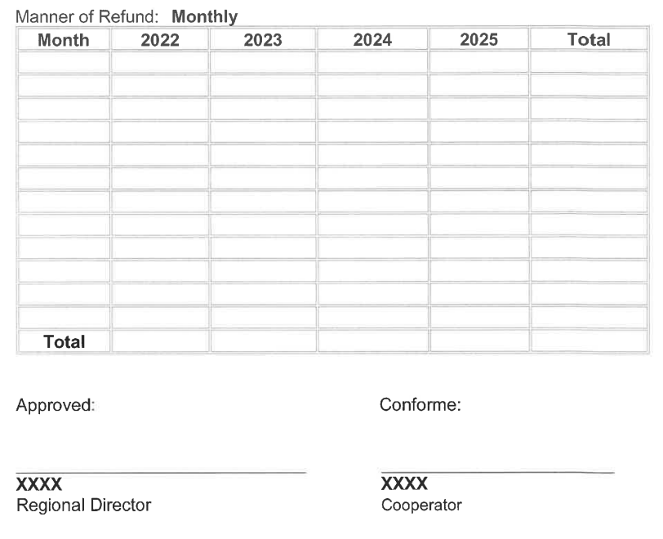
XXX

XXX

XXX

XXXto XXX

 |  |  |  | Disbursement
Particulars | Amount Approved | Approved Realignment | Amount Released | Previously Reported | This Report | Total Expenditure | Unexpended Balance | Accounts Payable
 |  |  |  |  |  | (3)+(4) | {2)-(5)
 |  | '1) | (2) | (3) | (4) | (5) | 16) | (7)
Maintenance
& Operating Expenses
Sub-total
Equipment Outlay
Sub-total
GRAND TOTAL
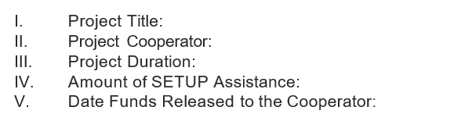

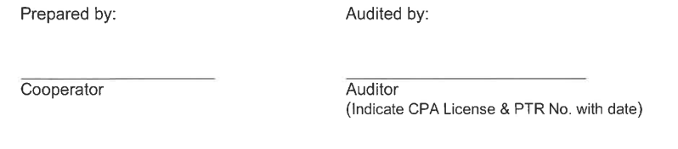
ANNEX E

SETUP Form 004 - Audited Financial Report (as of______)

